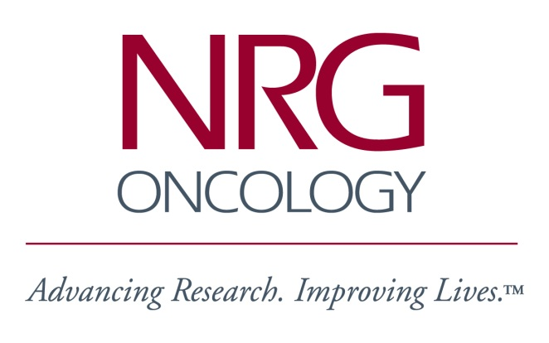
Semiannual Meeting
Friday, July 13, 2018
12:00 – 1:00 pm
Room 408 - 409

NRG-GU006 Training Session
A Phase II, Double-Blinded, Placebo Controlled Randomized Trial of Salvage Radiotherapy with or Without Enhanced Anti-Androgen Therapy with Apalutamide

AGENDA

Welcome & Introductions

Study Design Overview
- Background and Rationale
- Study Endpoints
- Key Eligibility/Ineligibility Criteria
- Dosing
- Statistical Considerations
- Correlative Studies

Treatment Overview

Apalutamide Overview

Protocol Logistics

Data Management Overview

